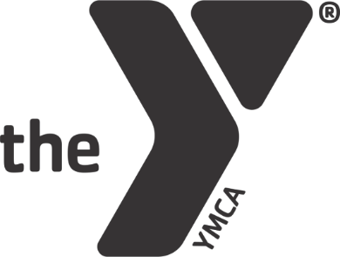

BUILDING A COALITION OF WOMEN LEADERS:
RISING FOR ACTION

Ready to step into your best self? Seeking greater clarity and confidence in your personal life and leadership style? If you answered “yes” to these questions, please join us for a deep dive of learning about The 15 Invaluable Laws of Growth. Each participant will receive a book that will guide our transformation. Throughout the eight week series, participants will not only learn from one another, but we will also learn from several community guest speakers. As a group, we will be selecting an action project that aligns with our goal of making a positive impact in our community.

TIME OF CLASS: 6:00 PM—7:30 PM

GATHERING TIME: 5:30 (Monday’s Market, grab a bite to eat, informal chat, etc.)
LOCATION: LEBANON VALLEY FAMILY YMCA DEPOT BOARD ROOM

DATES OF CLASS: July 15th, July 22nd, July 29th, August 5th, August19th,
September 16th, September 23rd, September 30th

FACILITATOR: Marianne T. Bartley, Ed.D., Time to Think, LLC, Founder

COST: $20 deposit to Time to Think, LLC – Refundable at the conclusion of the class. The program is sponsored by the Lebanon County Commission for Women.

APPLY: Limited Enrollment. Apply today by responding to marianne.bartley@comcast.net or Time2ThinkLLC@gmail.com. Put “RISING FOR ACTION” in the subject line.

